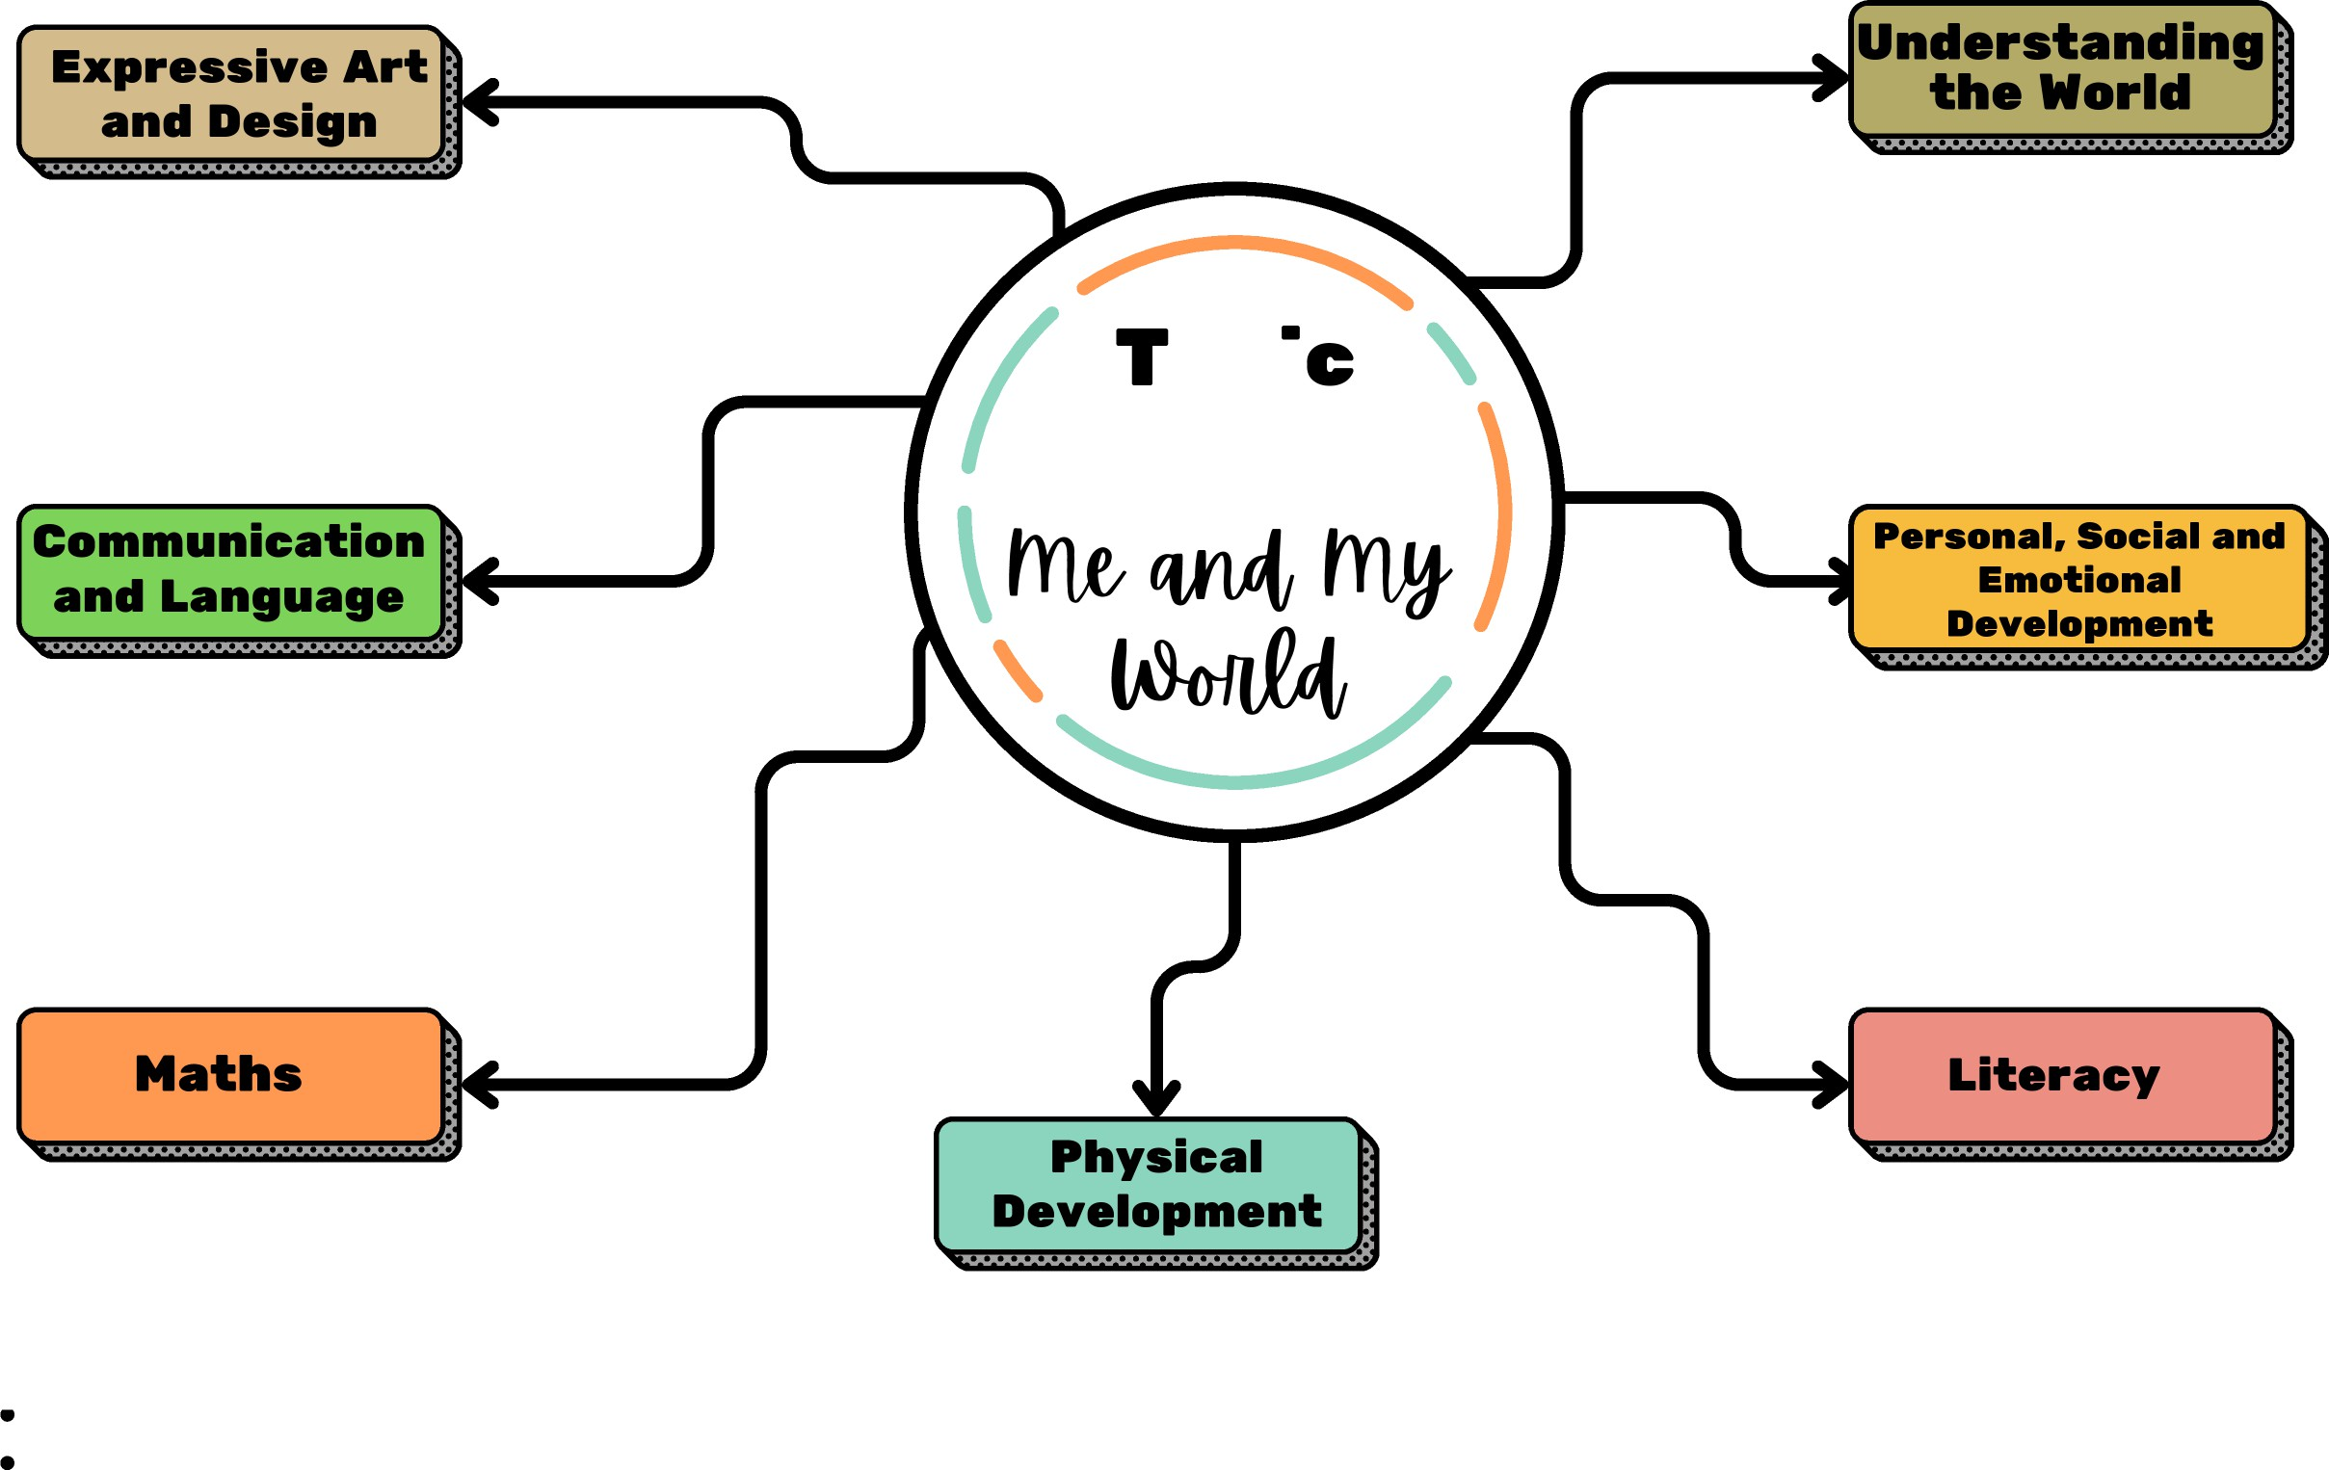


We will be creating self- portraits and exploring works by Vincent Van Gogh

We will be taking part in discussions and talk routines, as well as learning songs and rhymes.

We will be subitizing, counting, and following the topics:
Match, Sort, Compare
Measuring patterns

Overview

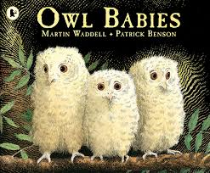

We will be developing our fine motor skills and engaging in a range of movement games in PE.
We will be celebrating the season of Autumn and learning about the harvest.
We will learn about owls, and other nocturnal creatures.

We will be talking about ourselves and our families. We will also be making friends, and learning routines to follow.

We will be following the Little Wandle Phonics scheme, as we start our journey
as readers and writers.
We will also be enjoying a range of quality texts such as our focus text Owl Babies.

