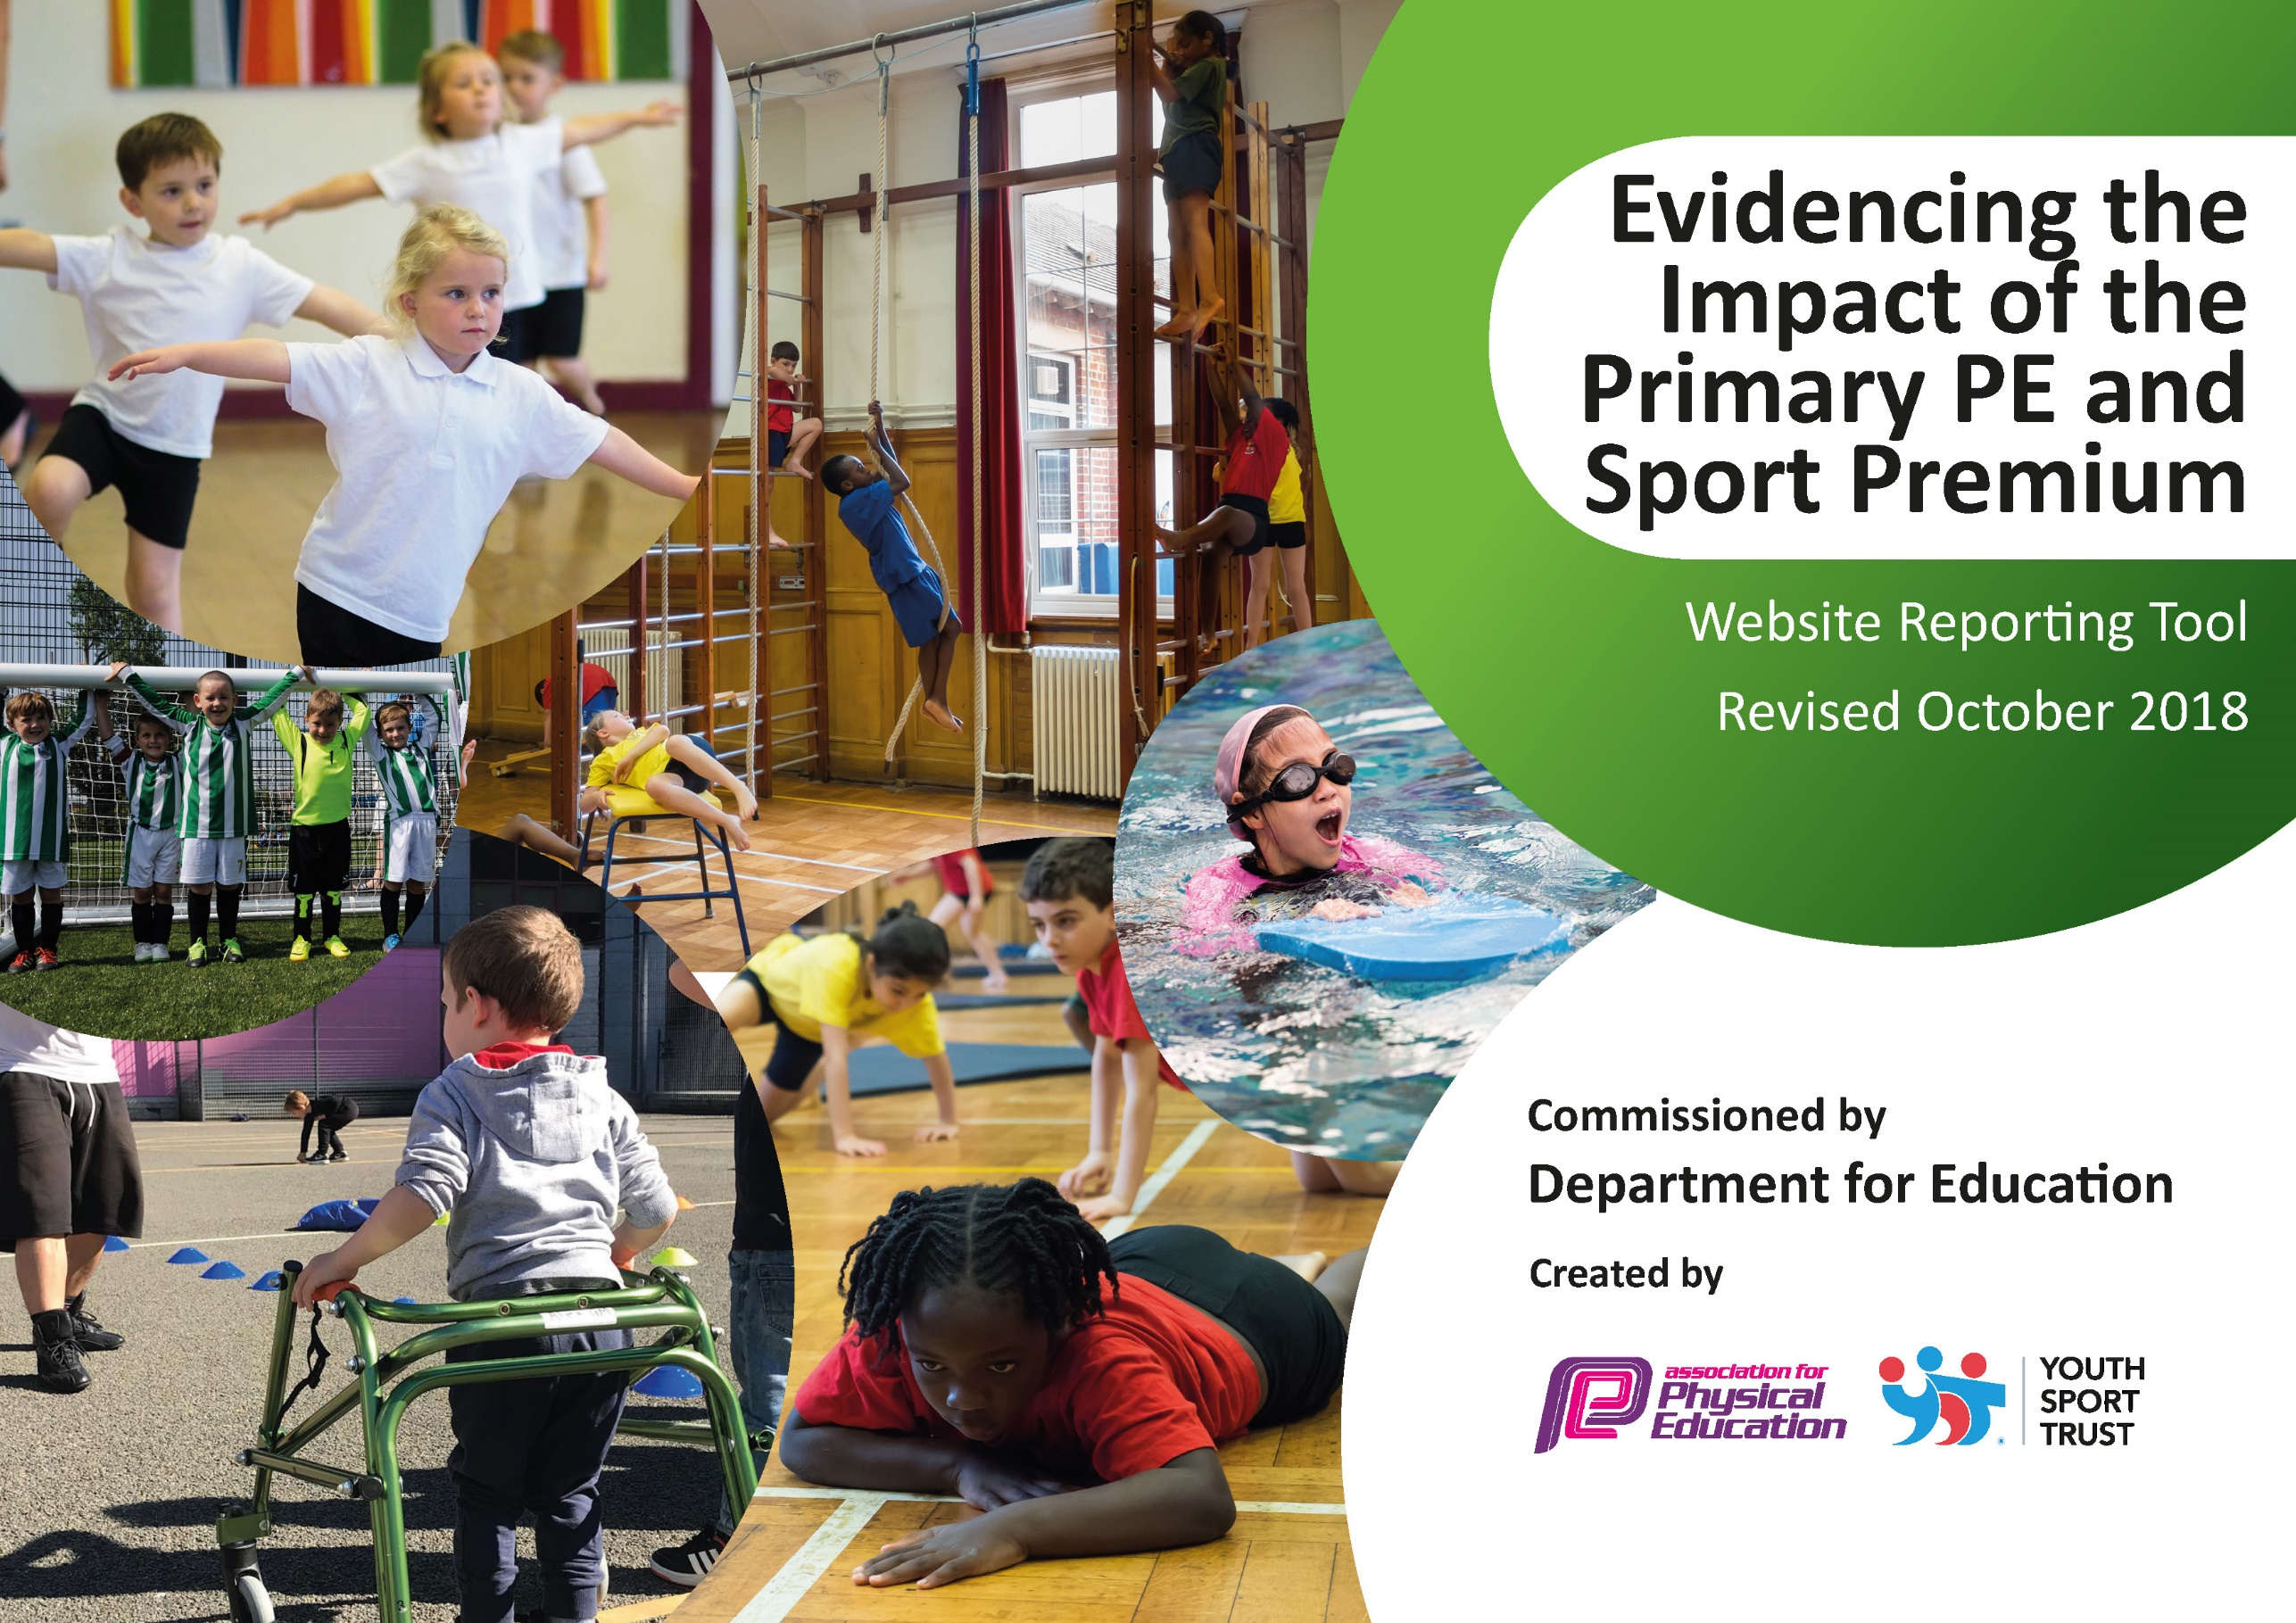
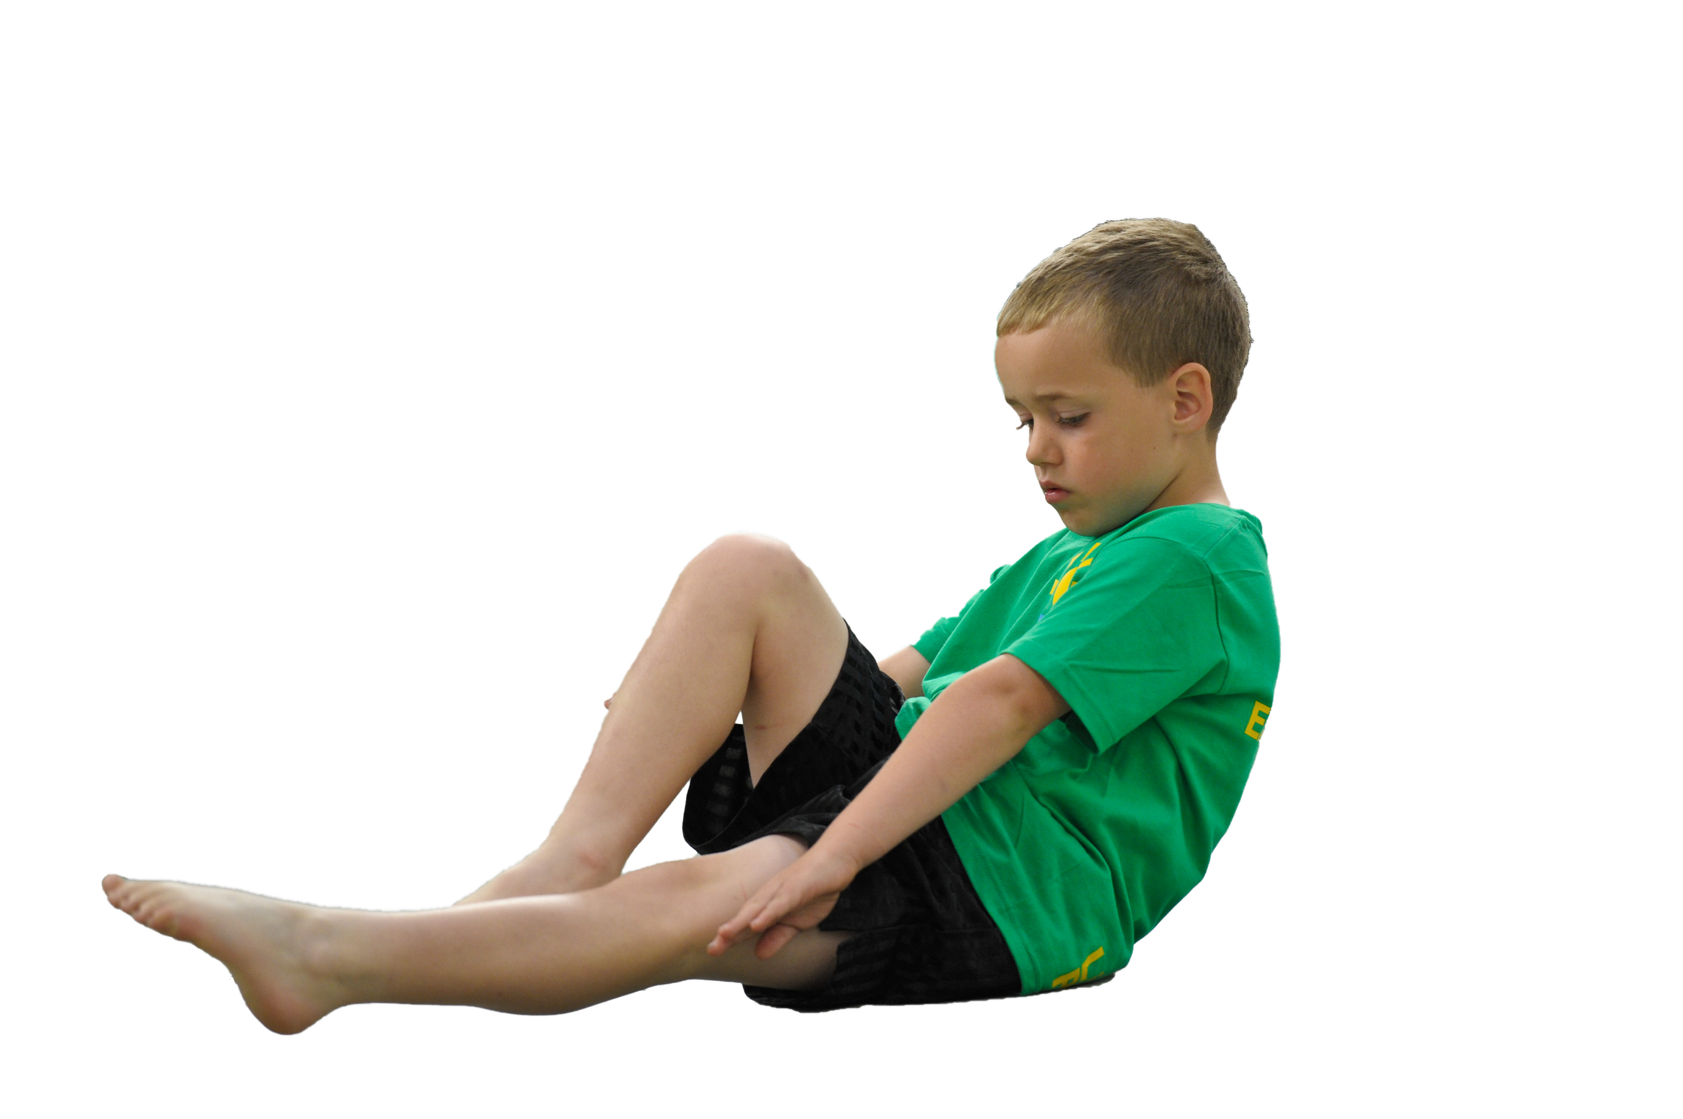
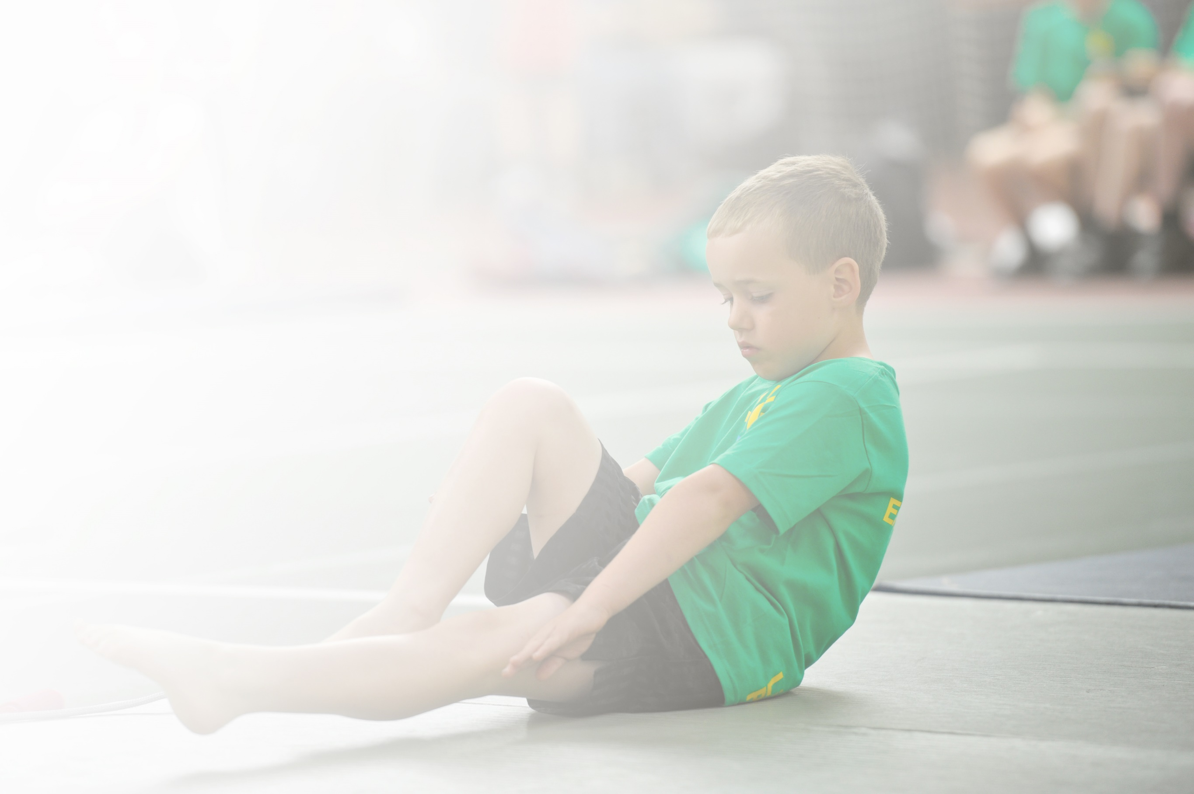
Schools must use the funding to make additional and sustainable improvements to the quality of Physical Education, Sport and Physical Activity (PESPA) they offer. This means that you should use the Primary PE and Sport Premium to:

- Develop or add to the PESPA activities that your school already offer
- Build capacity and capability within the school to ensure that improvements made now will benefit pupils joining the school in future years

Please visit gov.uk for the revised DfE guidance including the 5 key indicators across which schools should demonstrate an improvement. This document will help you to review your provision and to report
your spend. DfE encourages schools to use this template as an effective way of meeting the reporting requirements of the Primary PE and Sport Premium.

We recommend you start by reflecting on the impact of current provision and reviewing the previous
spend. Under the Ofsted Schools Inspection Framework, inspectors will assess how effectively leaders use the Primary PE and Sport Premium and measure its impact on outcomes for pupils, and how effectively governors hold them to account for this.

Schools are required to publish details of how they spend this funding as well as on the impact it has on pupils’ PE and sport participation and attainment by the end of the summer term or by 31 July 2019 at the
latest.
We recommend regularly updating the table and publishing it
on your website throughout the year, as evidence of your
ongoing review into how you are using the money to
secure maximum, sustainable impact. To see an
example of how to complete the table please
click HERE.

Support for review and reflection - considering the 5 key indicators from DfE, what development needs are a priority for your setting and your students now and why? Use the space below to reflect on previous spend, identify current need and priorities for the future.

Key achievements to date: | Areas for further improvement and baseline evidence of need:

Meeting national curriculum requirements for swimming and water safety | Please complete all of the below:
What percentage of your current Year 6 cohort swim competently, confidently and proficiently over a distance of at least 25 metres?
N.B. Even though your children may swim in another year please report on their attainment on leaving
primary school.
What percentage of your current Year 6 cohort use a range of strokes effectively [for example, front crawl, backstroke and breaststroke]?
What percentage of your current Year 6 cohort perform safe self-rescue in different water-based situations?
Schools can choose to use the Primary PE and Sport Premium to provide additional provision for swimming but this must be for activity over and above the national curriculum requirements. Have you used it in this way? | Yes CPD Training for extra staff to ensure smaller groups and more individual teaching

Action Plan and Budget Tracking
Capture your intended annual spend against the 5 key indicators. Clarify the success criteria and evidence of impact that you intend to measure to evaluate for students today and for the future.

Academic Year: 2020 / 21 | Total fund allocated: £17470 + | Date Updated: Sept 2020
Key indicator 1: The engagement of all pupils in regular physical activity – Chief Medical Officer guidelines recommend that primary school children undertake at least 30 minutes of physical activity a day in school |  |  |  | Percentage of total allocation:
School focus with clarity on intended impact on pupils: | Actions to achieve: | Funding allocated: | Evidence and impact: | Sustainability and suggested next steps:
Create active lessons within school day  Development of yoga lessons for all children (r-6) both in school and remotely  Development of staff confidence and knowledge of yoga/relaxation techniques (CPD) | Maths of the Day Training and on-line resource to deliver Active Maths/English lessons  Online CPD training for staff on use of Teach Active  Mindful Minisworkshop to encourage exercise and healthy eating to all classes in school  Yoga Bugs on line lessons  Yoga Bugs staff training | £975  £397  £1000 |  | Continue to fund and promote active lessons within school.  Embed in Maths policy
Key indicator 2: The profile of PESSPA being raised across the school as a tool for whole school improvement |  |  |  | Percentage of total allocation:
School focus with clarity on intended impact on pupils: | Actions to achieve: | Funding allocated: | Evidence and impact: | Sustainability and suggested next steps:
Responsibility for pupils to lead at play times.  Play leaders to encourage involvement and behaviour within school. | MSL Sports Leadership UK Playmaker Award  Playtime leaders kits and equipment  Development of pal training and action plan | £412  £150  £260  £5000 |  | Rolling programme of play leader training so that each play leader has a 2 year role of learning then leading  Use of Sports Organising Committee to promote Opal play  Use of playtime supervisors/ governors/parents

Key indicator 3: Increased confidence, knowledge and skills of all staff in teaching PE and sport |  |  |  | Percentage of total allocation:
School focus with clarity on intended  impact on pupils: | Actions to achieve: | Funding  allocated: | Evidence and impact: | Sustainability and suggested  next steps:
Staff training for swimming courses to allow staff to take individual classes unsupervised. | Level 1 & 2 swimming course and release time. | £1500 |  | On-going programme of CPD identified via staff questionnaire
Key indicator 4: Broader experience of a range of sports and activities offered to all pupils |  |  |  | Percentage of total allocation:
School focus with clarity on intended  impact on pupils: | Actions to achieve: | Funding  allocated: | Evidence and impact: | Sustainability and suggested  next steps:
Additional achievements:  Introduce a wider range of sports on offer.  Focus on taster days.  Inter-house competitions.  Development of extra skills and knowledge | Sport2day  Circus4schools  Freestyle football  West End in schools  Agilitas Schools Games Day  Bikeability courses (balance, bikeability, maintenance) | £2000  £500  £500  £1000  £400  £312  4 x £120 |  | Signposted to relevant local clubs  Bikeability training to be on-going funded via school(if necessary) or volunteers
Key indicator 5: Increased participation in competitive sport |  |  |  | Percentage of total allocation:
School focus with clarity on intended  impact on pupils: | Actions to achieve: | Funding  allocated: | Evidence and impact: | Sustainability and suggested  next steps:
Entry into inter school competitions within Lincs SE Sports Partnership.  Entry for both “A” “B” and SEN teams.  Provide opportunity to select, coach and practice for various team sports. | Agilitas Silver Partnership membership  Transport costs (10 events)  Supply/release time for coaches  Equipment for respective sports | £300  £500  (£120) tag rugby  £1200 |  | On-going programme  Separate programme using contacts developed through Agilitas Network meetings

