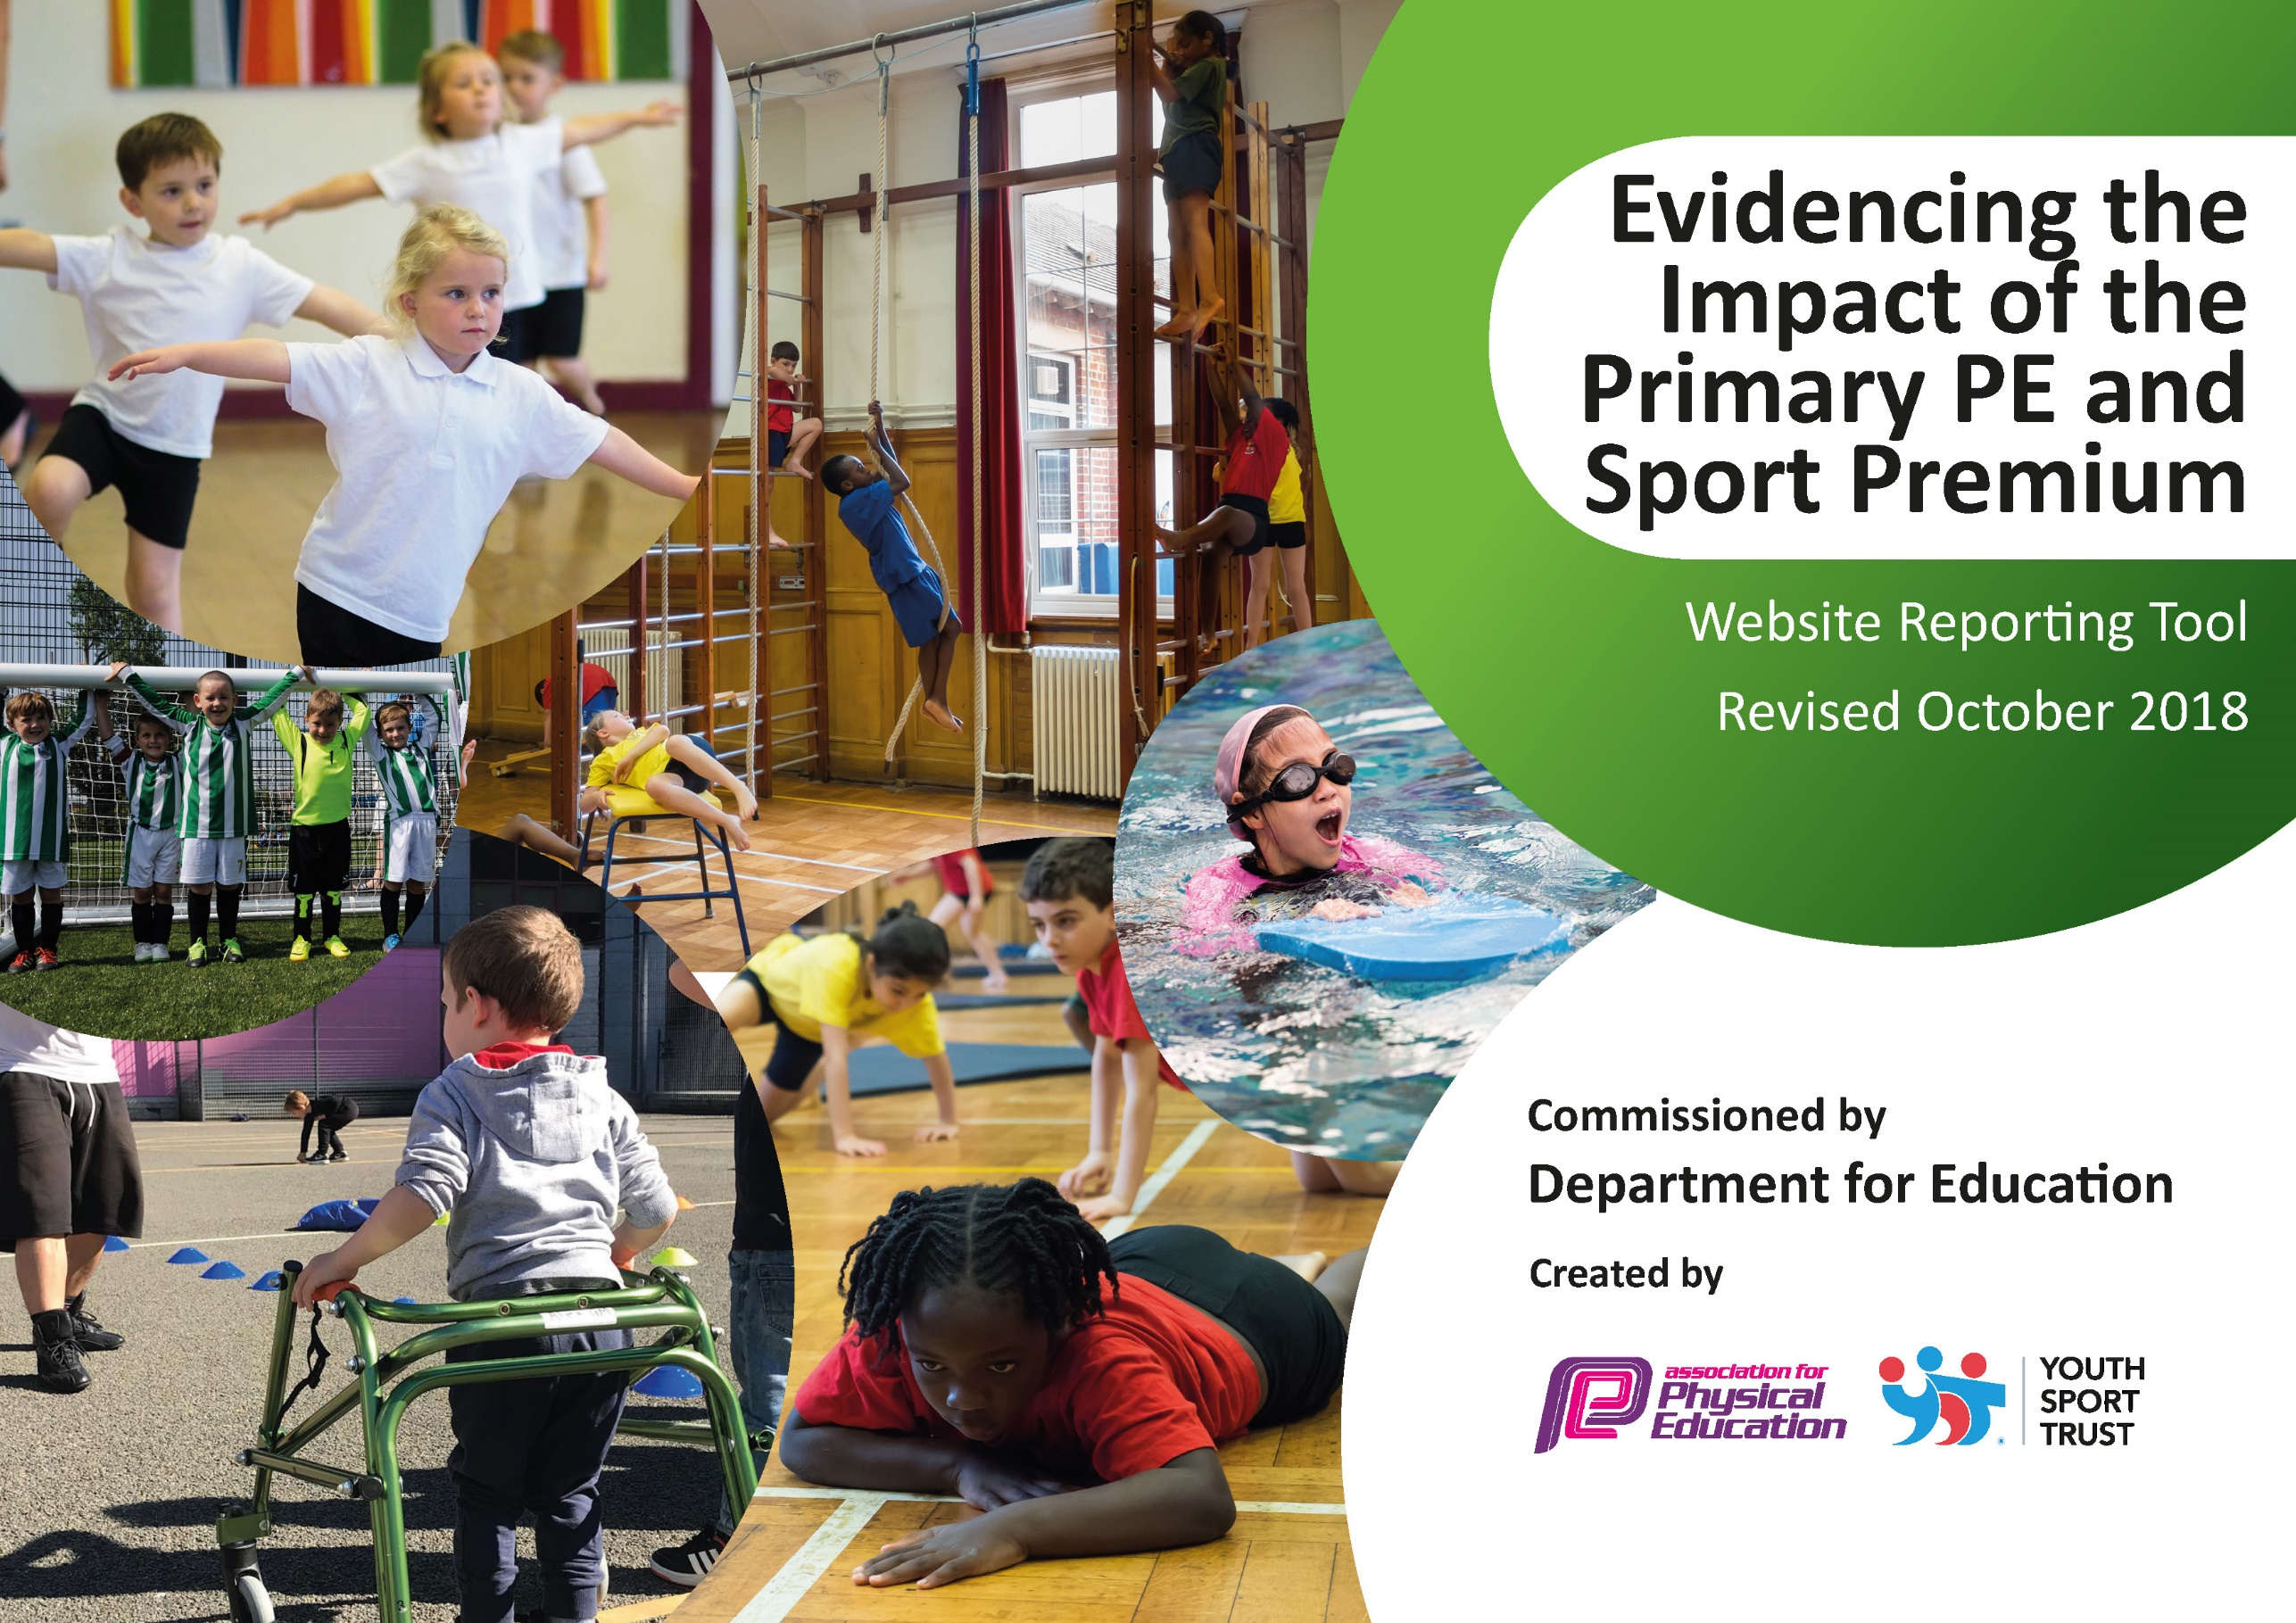
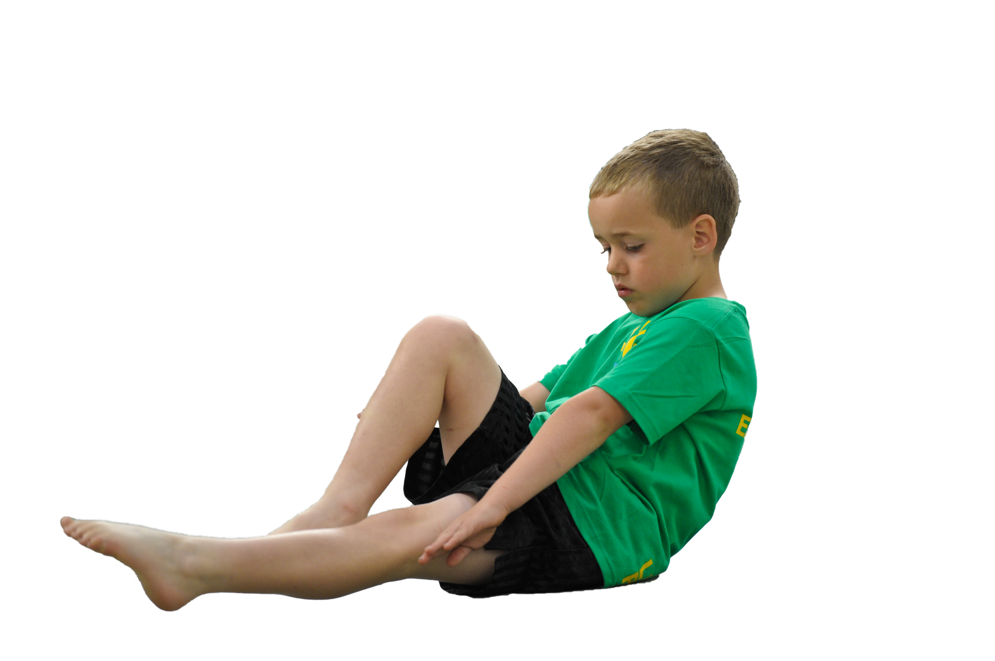
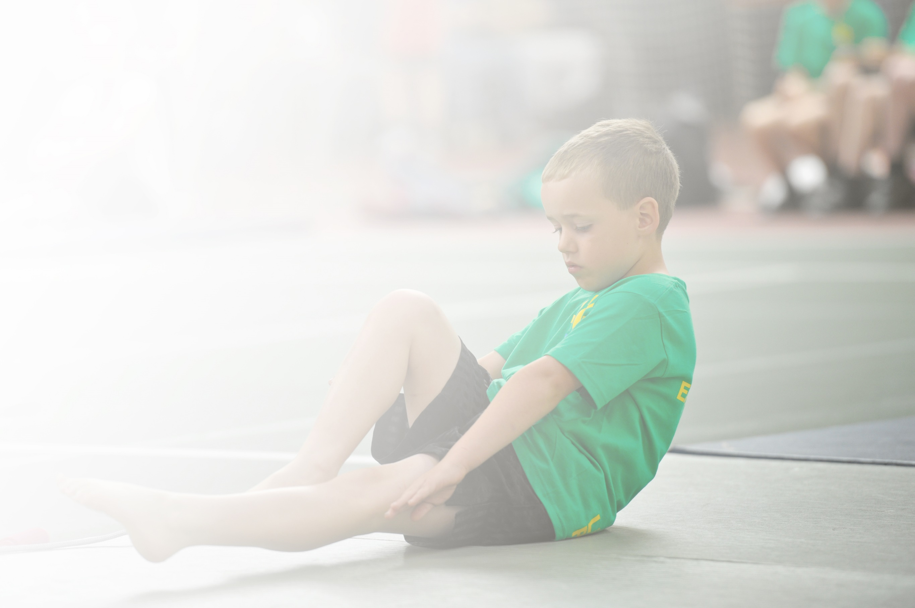
Schools must use the funding to make additional and sustainable improvements to the quality of Physical Education, Sport and Physical Activity (PESPA) they offer. This means that you should use the Primary PE and Sport Premium to:

- Develop or add to the PESPA activities that your school already offer
- Build capacity and capability within the school to ensure that improvements made now will benefit pupils joining the school in future years

Please visit gov.uk for the revised DfE guidance including the 5 key indicators across which schools should demonstrate an improvement. This document will help you to review your provision and to report
your spend. DfE encourages schools to use this template as an effective way of meeting the reporting requirements of the Primary PE and Sport Premium.

We recommend you start by reflecting on the impact of current provision and reviewing the previous
spend. Under the Ofsted Schools Inspection Framework, inspectors will assess how effectively leaders use the Primary PE and Sport Premium and measure its impact on outcomes for pupils, and how effectively governors hold them to account for this.

Schools are required to publish details of how they spend this funding as well as on the impact it has on pupils’ PE and sport participation and attainment by the end of the summer term at the
latest.
We recommend regularly updating the table and publishing it
on your website throughout the year, as evidence of your
ongoing review into how you are using the money to
secure maximum, sustainable impact. To see an
example of how to complete the table please
click HERE.

Support for review and reflection - considering the 5 key indicators from DfE, what development needs are a priority for your setting and your students now and why? Use the space below to reflect on previous spend, identify current need and priorities for the future.

Key achievements to date: | Areas for further improvement and baseline evidence of need:
P.E. equipment easily accessible for use within lessons, breaktime and wrap around care.  Increased outside gym equipment available to all children.  Developing play leader scheme. | Playleaders and school culture of break time play to be developed via the OPAL programme. 18-month programme beginning in April 2022.  Inter school competition to be increased via Discovery Sports.

Meeting national curriculum requirements for swimming and water safety | Please complete all of the below:
What percentage of your current Year 6 cohort swim competently, confidently and proficiently over a distance of at least 25 metres?  N.B. Even though your children may swim in another year please report on their attainment on leaving  primary school. | 88%
What percentage of your current Year 6 cohort use a range of strokes effectively [for example, front crawl, backstroke and breaststroke]? | 46%
What percentage of your current Year 6 cohort perform safe self-rescue in different water-based situations? | 69%
Schools can choose to use the Primary PE and Sport Premium to provide additional provision for swimming but this must be for activity over and above the national curriculum requirements. Have you used it in this way? | Yes CPD Training for extra staff to ensure smaller groups and more individual teaching

Action Plan and Budget Tracking
Capture your intended annual spend against the 5 key indicators. Clarify the success criteria and evidence of impact that you intend to measure to evaluate for students today and for the future.

Academic Year: 2021/22 | Total fund allocated: £17470 + £10700 (carry over from previous year) | Date Updated: July 2022
Key indicator 1: The engagement of all pupils in regular physical activity – Chief Medical Officer guidelines recommend that primary school children undertake at least 30 minutes of physical activity a day in school |  |  |  | Percentage of total allocation:
 |  |  |  | 12%
School focus with clarity on intended impact on pupils: | Actions to achieve: | Funding allocated: | Evidence and impact: | Sustainability and suggested next steps:
Create active lessons within school day  Development of yoga lessons for all children (r-6) both in school and remotely  Development of staff confidence and knowledge of yoga/relaxation techniques (CPD) | Maths of the Day Training and on-line resource to deliver Active Maths/English lessons  Online CPD training for staff on use of Teach Active  Yoga Bugs on line lessons  Yoga Bugs staff training | £2499  £1000 | All classes planning and using Active Maths as a starter/ beginning of unit or plenary of lesson or unit.  Adding 30 minutes in a week to count towards the 30mins per day.  YogaBugs extensively used for P.E. lessons during lockdown.  On-line lessons scheduled and planned for 2 x 1 hour per class per week. Anecdotally, parents and children reported using the lessons independently. | Continue to fund and promote active lessons within school.  Embed in Maths policy  Continued funding as “mindfullness” will remain important post Covid
Key indicator 2: The profile of PESSPA being raised across the school as a tool for whole school improvement |  |  |  | Percentage of total allocation:
 |  |  |  | 70%
School focus with clarity on intended impact on pupils: | Actions to achieve: | Funding allocated: | Evidence and impact: | Sustainability and suggested next steps:
Responsibility for pupils to lead at play times.  Play leaders to encourage involvement and behaviour within school.  OPAL training to revolutionise break times and school attitude to play. Moving from traditional ball games to child-led imaginative play. | MSL Sports Leadership UK Playmaker Award  Playtime leaders kits and equipment  Discovery training (Maths on the Move) intervention programme to commence in Sept 2022 (Programme began in June 2022 )  Development of Opal training and action plan | £412  £403  £7900  £6700  £4500 | Beginning of shift in emphasis. Can already see changes in attitude at breaktimes.  Initial survey completed and will be revisited on training day in Sept 2022.  Training highlighted as priority for lunchtime staff (Play leaders) | Rolling programme of play leader training so that each play leader has a 2 year role of learning then leading.  Playleader training to be encompassed within Discovery Sports for 22-23  Use of Sports Organising Committee to promote Opal play  Use of playtime supervisors/ governors/parents  Play Supervisor appointed and training stated to lead project in future

Key indicator 3: Increased confidence, knowledge and skills of all staff in teaching PE and sport |  |  |  | Percentage of total allocation:
 |  |  |  | 1`%
School focus with clarity on intended  impact on pupils: | Actions to achieve: | Funding  allocated: | Evidence and impact: | Sustainability and suggested  next steps:
Staff training for swimming courses to allow staff to take individual classes unsupervised.  New and comprehensive P.E. Planning which is more alligned to current P.E. curriculum and user friendly | Level 1 & 2 swimming course and release time.  P.E. Planning subscription | £1500  £165 | Not completed this year but high priority for future years  Used by all staff and embedded in LTP and MTP | On-going programme of CPD identified via staff questionnaire  Continuing and checked by monitoring and lesson observation
Key indicator 4: Broader experience of a range of sports and activities offered to all pupils |  |  |  | Percentage of total allocation:
 |  |  |  | 16%
School focus with clarity on intended  impact on pupils: | Actions to achieve: | Funding  allocated: | Evidence and impact: | Sustainability and suggested  next steps:
Additional achievements:  Introduce a wider range of sports on offer.  Focus on taster days.  Development of extra skills and knowledge | Sport2day  Elite Sport Academy  Circus4schools  Freestyle football  West End in schools  Agilitas Schools Games Day  Bikeability courses (balance, bikeability, maintenance) | £2000  £180  £650  £375  £997  £400  4 x £120 | Whole School Taster days in a variety of dance, circus skills and football skills through all ages . | Signposted to relevant local clubs  Continued and developed through after school clubs.  Staff CPD and confidence allows for further lessons.  Bikeability training to be on-going funded via school(if necessary) or volunteers
Key indicator 5: Increased participation in competitive sport |  |  |  | Percentage of total allocation:
 |  |  |  | 1%
School focus with clarity on intended  impact on pupils: | Actions to achieve: | Funding  allocated: | Evidence and impact: | Sustainability and suggested  next steps:
Entry into inter school competitions within Lincs SE Sports Partnership.  Sports2Day  New competitions and inter school competitions (Kho Kho, Kabbadi and Mini Olympics) | Agilitas Silver Partnership membership  Sports2Day on site and organising inter school competitions | £300  TBC |  | On-going programme  Separate programme using contacts developed through Agilitas Network meetings

